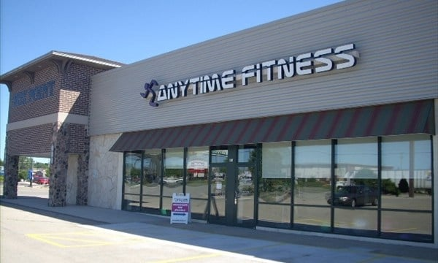

Employees
AN EXCLUSIVE OFFER FROM NEENAH ANYTIME FITNESS!
        - 24/7 ACCESS TO ALL 3000 CLUBS WORLDWIDE
        - 24/7 TANNING AND HYRDO MASSAGE
        - COMPLIMENTARY PERSONAL TRAINING SESSION
        - ANYTIME FITNESS APP
LET’S WORK TOGETHER AND MAKE HEALTHY HAPPEN!
Take a Photo of this flyer and bring it to our Neenah Location for your:
1st month free, hour complimentary training session and month of tanning or hydro massage

o

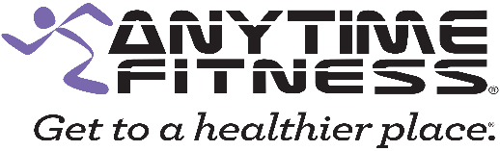
860 Fox Point Plaza | Neenah, WI
neenahwi@anytimefitness.com I 920.725.0500

